Find me an internship already

(Documentation)

Student: Vasile Suciu

Group: 30434

Other team members: Novacean Ligia Nicoleta, Samarghitan Flaviu, Supuran Marius

Problem statement

Design and build an application to aid students in finding an internship based on their preferences (technology, duration, experience, location).

The application has been developed in Python and deployed on Google Cloud. It uses pymysql framework to connect to a data base and rpyc to help modules running on different machines to communicate with one another. It has a client-server architecture and it is based on 3 different prism case studies:

Crowds Protocol <http://www.prismmodelchecker.org/casestudies/crowds.php>

IPv4 Zeroconf Protocol <http://www.prismmodelchecker.org/casestudies/zeroconf.php>

Stable Matchings <http://www.prismmodelchecker.org/casestudies/stable_matching.php>

Out of the three I am responsible for implementing the stable matching. Each student looking for an internship has access to a client application. The client will then connect to a server (one for each client, hence stable matching) and request an internship based on several criteria. A server can accept connections from only one client (the first who performs a request). If another client tries to connect, it is disconnected and has to look for a different server.

Specification

The application presented is meant to help students in finding the right internship according to their preferences. It uses stable matching to pair each client (student) to a server. The server performs the actual search for the internship and returns the result. To ensure anonymity the clients can also communicate between them using crowds protocol. Thus they may issue requests for themselves or other clients in the network. In this manner the servers are unaware who is the original author of the request, thus preserving the privacy of the students. The IPv4 zeroconf protocol is normally used to assign IP’s in a network such that no conflicts appear.

Stable Matching Case Study (Gale and Shapley approach)

**dtmc** *// model is a DTMC/Markov chain*

*//------------------------------------------------------*

*// PREFERENCE LISTS*

*// man i prefers woman j over woman k if mij>mik*

*// woman i prefers man j over man k if wij>wik*

*// preference list for men*

**const** **int** m11=3;

**const** **int** m12=2;

**const** **int** m13=1;

**const** **int** m22=3;

**const** **int** m23=2;

**const** **int** m21=1;

**const** **int** m33=3;

**const** **int** m31=2;

**const** **int** m32=1;

*// preference list for women*

**const** **int** w12=3;

**const** **int** w13=2;

**const** **int** w11=1;

**const** **int** w23=3;

**const** **int** w21=2;

**const** **int** w22=1;

**const** **int** w31=3;

**const** **int** w32=2;

**const** **int** w33=1;

*//------------------------------------------------------*

*// constants used in renaming*

**const** **int** N1=1;

**const** **int** N2=2;

**const** **int** N3=3;

*//------------------------------------------------------*

*// module for first man*

**module** man1

*// current matching (0 means no matching)*

m1 : [0..3];

*// wants to change matching*

[e11] m1=0 | (m1=1 & m11>m11)|(m1=2 & m11>m12)|(m1=3 & m11>m13) -> (m1'=1);

[e12] m1=0 | (m1=1 & m12>m11)|(m1=2 & m12>m12)|(m1=3 & m12>m13) -> (m1'=2);

[e13] m1=0 | (m1=1 & m13>m11)|(m1=2 & m13>m12)|(m1=3 & m13>m13) -> (m1'=3);

*// one of the other pairs change so may need to reset matching*

[e21] **true** -> (m1'=(m1=1)?0:m1);

[e31] **true** -> (m1'=(m1=1)?0:m1);

[e22] **true** -> (m1'=(m1=2)?0:m1);

[e32] **true** -> (m1'=(m1=2)?0:m1);

[e23] **true** -> (m1'=(m1=3)?0:m1);

[e33] **true** -> (m1'=(m1=3)?0:m1);

**endmodule**

*// construct further men through renaming*

**module** man2=man1[m1=m2, m11=m21, e11=e21, e12=e22, e13=e23, m12=m22, e21=e31, e22=e32, e23=e33, m13=m23, e31=e11, e32=e12, e33=e13 ] **endmodule**

**module** man3=man1[m1=m3, m11=m31, e11=e31, e12=e32, e13=e33, m12=m32, e21=e11, e22=e12, e23=e13, m13=m33, e31=e21, e32=e22, e33=e23 ] **endmodule**

*//------------------------------------------------------*

*// module for first woman*

**module** woman1

*// do not need to store the matching (can work it out from the men's variables)*

*// man 1 wants to change*

[e11] ( m1!=N1 & m2!=N1 & m3!=N1 ) | (m1=N1 & w11>w11)|(m2=N1 & w11>w12)|(m3=N1 & w11>w13) -> **true**;

[e21] ( m1!=N1 & m2!=N1 & m3!=N1 ) | (m1=N1 & w12>w11)|(m2=N1 & w12>w12)|(m3=N1 & w12>w13) -> **true**;

[e31] ( m1!=N1 & m2!=N1 & m3!=N1 ) | (m1=N1 & w13>w11)|(m2=N1 & w13>w12)|(m3=N1 & w13>w13) -> **true**;

**endmodule**

*// construct further women through renaming*

**module** woman2=woman1[ N1=N2, w11=w21, e11=e12, e21=e22, e31=e32, w12=w22, e12=e13, e22=e23, e32=e33, w13=w23, e13=e11, e23=e21, e33=e31 ] **endmodule**

**module** woman3=woman1[ N1=N3, w11=w31, e11=e13, e21=e23, e31=e33, w12=w32, e12=e11, e22=e21, e32=e31, w13=w33, e13=e12, e23=e22, e33=e32 ] **endmodule**

*//------------------------------------------------------*

*// reward structure: expected rounds*

**rewards** "rounds"

**true** : 1;

**endrewards**

Experiments

*// probability reached a stable matching by round R*

**const** **int** r; *// bound of number of rounds*

**P**=?[ **F**<=r "deadlock" ]

*// expected number of rounds to reach a stable matching*

**R**{"rounds"}=? [ **F** "deadlock" ]

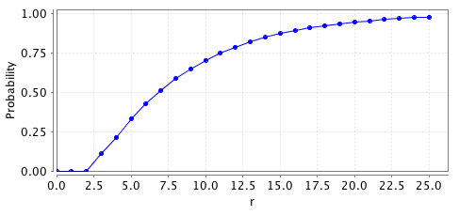

Use Case Diagram

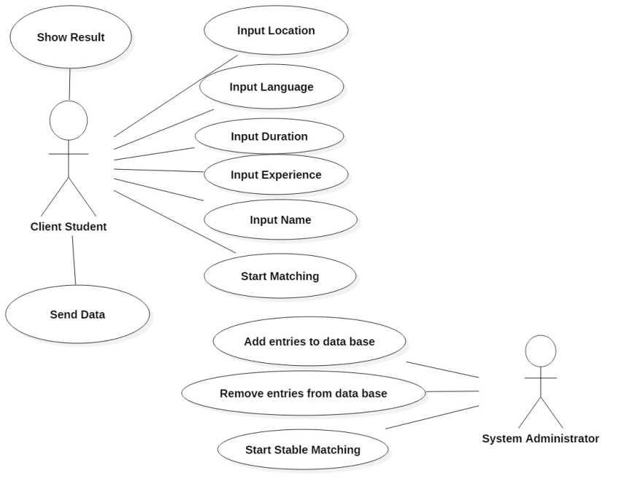

Architecture and design

The application has a client-server architecture. No particular design patterns have been required.

Deployment Diagram

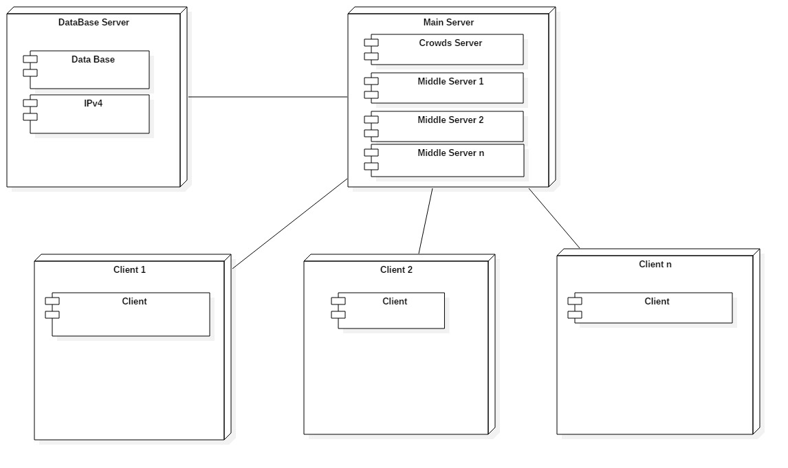

Class Diagram

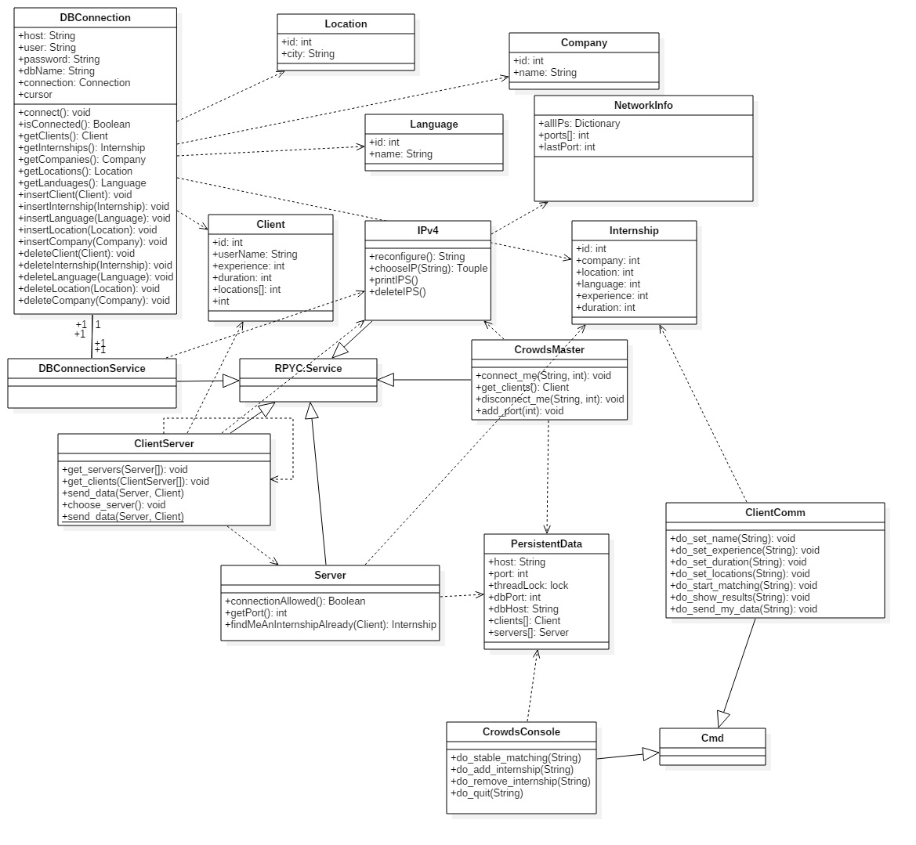

Source Code

**rpDBMethods.py**

|  |
| --- |
| import pymysql |
|  | import thread |
|  |  |
|  | import rpyc |
|  |  |
|  |  |
|  | class Client: |
|  | def __init__(self): |
|  | self.id = 0 |
|  | self.userName = "" |
|  | self.experience = 0 |
|  | self.duration = 0 |
|  | self.password_encr = "" |
|  | self.password_salt = "" |
|  | self.locations = [] |
|  | self.languages = [] |
|  |  |
|  |  |
|  | class Internship: |
|  | def __init__(self): |
|  | self.id = 0 |
|  | self.company = 0 |
|  | self.location = 0 |
|  | self.language = 0 |
|  | self.experience = 0 |
|  | self.duration = 0 |
|  |  |
|  | def __str__(self): |
|  | stri = str(self.id)+" "+str(self.company)+" +"+str(self.location)+" "+str(self.language)+" "+str(self.experience)+" "+str(self.duration) |
|  | return stri |
|  |  |
|  | def clone(self): |
|  | internship2 = Internship() |
|  | internship2.id = self.id |
|  | internship2.company = self.company |
|  | internship2.location = self.location |
|  | internship2.language = self.language |
|  | internship2.experience = self.experience |
|  | internship2.duration = self. duration |
|  | return internship2 |
|  |  |
|  |  |
|  | class Company: |
|  | def __init__(self): |
|  | self.id = 0 |
|  | self.name = "" |
|  |  |
|  |  |
|  | class Location: |
|  | def __init__(self): |
|  | self.id = 0 |
|  | self.city = "" |
|  |  |
|  |  |
|  | class Language: |
|  | def __init__(self): |
|  | self.id = 0 |
|  | self.name = "" |
|  |  |
|  |  |
|  | class DBConnectionService(rpyc.Service): |
|  | class exposed_DBConnection(object): |
|  | def __init__(self): |
|  | self.host = "localhost" |
|  | self.user = "root" |
|  | self.password = "10lase" |
|  | self.dbName = "internship" |
|  | self.connection = None |
|  | self.cursor = None |
|  |  |
|  | def connect(self): |
|  | self.connection = pymysql.connect(self.host, self.user, self.password, self.dbName) |
|  |  |
|  | def isConnected(self): |
|  | if self.connection is None: |
|  | return False |
|  | return True |
|  |  |
|  | def exposed_getClients(self): |
|  | self.connect() |
|  | self.cursor = self.connection.cursor() |
|  | clients = [] |
|  | self.cursor.execute("SELECT * FROM Client") |
|  | resultSet = self.cursor.fetchall() |
|  | for row in resultSet: |
|  | client = Client() |
|  | client.id = row[0] |
|  | client.userName = row[1] |
|  | client.experience = row[4] |
|  | client.duration = row[5] |
|  | self.cursor.execute("SELECT * FROM Client_Language WHERE client_id=" + str(client.id)) |
|  | resultSet2 = self.cursor.fetchall() |
|  | for e in resultSet2: |
|  | client.languages.append(e[0]) |
|  | self.cursor.execute("SELECT * FROM Client_Location WHERE client_id=" + str(client.id)) |
|  | resultSet2 = self.cursor.fetchall() |
|  | for e in resultSet2: |
|  | client.languages.append(e[1]) |
|  | clients.append(client) |
|  | self.cursor.close() |
|  | self.connection.close() |
|  | return clients |
|  |  |
|  | def exposed_getInternships(self): |
|  | self.connect() |
|  | self.cursor = self.connection.cursor() |
|  | internships = [] |
|  | self.cursor.execute("SELECT * FROM Internship") |
|  | resultSet = self.cursor.fetchall() |
|  | for row in resultSet: |
|  | internship = Internship() |
|  | internship.id = row[0] |
|  | internship.company = row[2] |
|  | internship.location = row[3] |
|  | internship.language = row[4] |
|  | internship.experience = row[5] |
|  | internship.duration = row[6] |
|  | internships.append(internship) |
|  | self.cursor.close() |
|  | self.connection.close() |
|  | return internships |
|  |  |
|  | def exposed_getCompanies(self): |
|  | self.connect() |
|  | self.cursor = self.connection.cursor() |
|  | companies = [] |
|  | sql = "SELECT * FROM Company" |
|  | self.cursor.execute(sql) |
|  | resultSet = self.cursor.fetchall() |
|  | for row in resultSet: |
|  | company = Company() |
|  | company.id = row[0] |
|  | company.name = row[1] |
|  | companies.append(company) |
|  | self.cursor.close() |
|  | self.connection.close() |
|  | return companies |
|  |  |
|  | def exposed_getLocations(self): |
|  | self.connect() |
|  | self.cursor = self.connection.cursor() |
|  | locations = [] |
|  | sql = "SELECT * FROM Location" |
|  | self.cursor.execute(sql) |
|  | resultSet = self.cursor.fetchall() |
|  | for row in resultSet: |
|  | location = Location() |
|  | location.id = row[0] |
|  | location.city = row[1] |
|  | locations.append(location) |
|  | self.cursor.close() |
|  | self.connection.close() |
|  | return locations |
|  |  |
|  | def exposed_getLanguages(self): |
|  | self.connect() |
|  | self.cursor = self.connection.cursor() |
|  | languages = [] |
|  | sql = "SELECT * FROM Language" |
|  | self.cursor.execute(sql) |
|  | resultSet = self.cursor.fetchall() |
|  | for row in resultSet: |
|  | language = Language() |
|  | language.id = row[0] |
|  | language.name = row[1] |
|  | languages.append(language) |
|  | self.cursor.close() |
|  | self.connection.close() |
|  | return languages |
|  |  |
|  | def exposed_insertClient(self, client): |
|  | self.connect() |
|  | self.cursor = self.connection.cursor() |
|  | sql = """INSERT INTO Clieant(client_id, username, password_encr, password_salt, |
|  | experience, duration) VALUES ('%d','%s','%s','%s','%d','%d')""" % \ |
|  | (client.id, client.userName, client.password_encr, client.password_salt, \ |
|  | client.experience, client.duration) |
|  | self.cursor.execute(sql) |
|  | for l in client.languages: |
|  | sql = """INSERT INTO Client_Language(language_id, client_id) |
|  | VALUES ('%d', '%d')""" % (l, client.id) |
|  | self.cursor.execute(sql) |
|  | for l in client.locations: |
|  | sql = """INSERT INTO Client_Location(client_id, location_id) |
|  | VALUES ('%d', '%d')""" % (client.id, l) |
|  | self.cursor.execute(sql) |
|  | self.connection.commit() |
|  | self.cursor.close() |
|  | self.connection.close() |
|  |  |
|  | def exposed_insertInternship(self, internship): |
|  | self.connect() |
|  | self.cursor = self.connection.cursor() |
|  | sql = """INSERT INTO Internship (internship_id, company_id, |
|  | location_id, language_id, experience, duration) values ('%d', '%d', |
|  | '%d', '%d', '%d', '%d')""" % (internship.id, internship.company, internship.location, \ |
|  | internship.language, internship.experience, internship.duration) |
|  | self.cursor.execute(sql) |
|  | self.connection.commit() |
|  | self.cursor.close() |
|  | self.connection.close() |
|  |  |
|  | def exposed_insertLanguage(self, language): |
|  | self.connect() |
|  | self.cursor = self.connection.cursor() |
|  | sql = """INSERT INTO Language (language_id, name) |
|  | values ('%d', '%s')""" % (language.id, language.name) |
|  | self.cursor.execute(sql) |
|  | self.connection.commit() |
|  | self.cursor.close() |
|  | self.connection.close() |
|  |  |
|  | def exposed_insertLocation(self, location): |
|  | self.connect() |
|  | self.cursor = self.connection.cursor() |
|  | sql = """INSERT INTO Location (location_id, city) |
|  | values ('%d', '%s')""" % (location.id, location.city) |
|  | self.cursor.execute(sql) |
|  | self.connection.commit() |
|  | self.cursor.close() |
|  | self.connection.close() |
|  |  |
|  | def exposed_insertCompany(self, company): |
|  | self.connect() |
|  | self.cursor = self.connection.cursor() |
|  | sql = """INSERT INTO Company (company_id, name) |
|  | values ('%d', '%s')""" % (company.id, company.name) |
|  | self.cursor.execute(sql) |
|  | self.connection.commit() |
|  | self.cursor.close() |
|  | self.connection.close() |
|  |  |
|  | def exposed_deleteClient(self, client): |
|  | self.connect() |
|  | self.cursor = self.connection.cursor() |
|  | sql = "DELETE FROM Client_Location WHERE client_id='%d'" % (client.id) |
|  | self.cursor.execute(sql) |
|  | sql = "DELETE FROM Client_Language WHERE client_id='%d'" % (client.id) |
|  | self.cursor.execute(sql) |
|  | sql = "DELETE FROM Client WHERE client_id='%d'" % (client.id) |
|  | self.cursor.execute(sql) |
|  | self.connection.commit() |
|  | self.cursor.close() |
|  | self.connection.close() |
|  |  |
|  | def exposed_deleteInternship(self, internship): |
|  | self.connect() |
|  | self.cursor = self.connection.cursor() |
|  | sql = "Delete FROM Internship where internship_id = '%d'" % internship.id |
|  | self.cursor.execute(sql) |
|  | self.connection.commit() |
|  | self.cursor.close() |
|  | self.connection.close() |
|  |  |
|  | def exposed_deleteLanguage(self, language): |
|  | self.connect() |
|  | self.cursor = self.connection.cursor() |
|  | sql = "DELETE FROM Internship WHERE language_id='%d'" % (language.id) |
|  | self.cursor.execute(sql) |
|  | sql = "DELETE FROM Client_Language WHERE language_id='%d'" % (language.id) |
|  | self.cursor.execute(sql) |
|  | sql = "DELETE FROM Language WHERE language_id='%d'" % (language.id) |
|  | self.cursor.execute(sql) |
|  | self.connection.commit() |
|  | self.cursor.close() |
|  | self.connection.close() |
|  |  |
|  | def exposed_deleteLocation(self, location): |
|  | self.connect() |
|  | self.cursor = self.connection.cursor() |
|  | sql = "DELETE FROM Client_Location WHERE location_id='%d'" % (location.id) |
|  | self.cursor.execute(sql) |
|  | sql = "DELETE FROM Internship WHERE location_id='%d'" % (location.id) |
|  | self.cursor.execute(sql) |
|  | sql = "DELETE FROM Location WHERE location_id='%d'" % (location.id) |
|  | self.cursor.execute(sql) |
|  | self.connection.commit() |
|  | self.cursor.close() |
|  | self.connection.close() |
|  |  |
|  | def exposed_deleteCompany(self, company): |
|  | self.connect() |
|  | self.cursor = self.connection.cursor() |
|  | sql = "DELETE FROM Internship WHERE company_id='%d'" % (company.id) |
|  | self.cursor.execute(sql) |
|  | sql = "DELETE FROM Company WHERE company_id='%d'" % (company.id) |
|  | self.cursor.execute(sql) |
|  | self.connection.commit() |
|  | self.cursor.close() |
|  | self.connection.close() |
|  |  |
|  | def exposed_Sal(self): |
|  | print("PaBafta") |
|  |  |
|  | def server_start(): |
|  | ThreadedServer(DBConnectionService, port=1234,protocol_config={"allow_public_attrs": True, "allow_all_attrs": True}).start() |
|  |  |
|  | from rpyc.utils.server import ThreadedServer |
|  |  |
|  | if __name__ == "__main__": |
|  | print "ok" |
|  | thread.start_new_thread(server_start,()) |
|  | print "also ok" |
|  | while 1==1: |
|  | pass |

**crowdsboss.py**

|  |
| --- |
| import rpyc |
|  | import subprocess |
|  | import socket |
|  | import thread |
|  | import os |
|  | import time |
|  | from cmd import Cmd |
|  | from rpyc.utils.server import ThreadedServer |
|  | from rpDBMethods import Client |
|  | from rpDBMethods import Internship |
|  | from rpDBMethods import Location |
|  | from rpDBMethods import Language |
|  | from rpDBMethods import Company |
|  |  |
|  | global data |
|  |  |
|  | class PersistentData(): |
|  | def __init__(self): |
|  | self.clients = [] |
|  | #self.clientsRPYC = [] |
|  | self.servers = [] |
|  | # to be changed accordingly |
|  | self.host = "10.142.0.3" |
|  | self.port = 1024 |
|  | self.dbHost = "10.142.0.2" |
|  | self.dbPort = 1234 |
|  |  |
|  | class CrowdsConsole(Cmd): |
|  | def do_stable_matching(self, args): |
|  | global data |
|  | ports = 1024 |
|  | for i in data.clients: |
|  | ports += 1 |
|  | thread.start_new_thread( |
|  | os.system, |
|  | ("python "+ "Server.py " + str(data.host) + " " + str(ports) + " " + str(data.dbHost) + " " + str(data.dbPort) + " " + str(data.host) + " " + str(data.port),)) |
|  | # get port of each server in a list |
|  | data.servers.append((data.host, ports)) |
|  | time.sleep(1) |
|  | for c in data.clients: |
|  | # name should be adjusted accordingly |
|  | conn = rpyc.connect(c[0], c[1], config={"allow_all_attrs": True}) |
|  | s = conn.root |
|  | s.get_servers(data.servers) |
|  | s.choose_server() |
|  | clients = list(data.clients) |
|  | clients.remove(c) |
|  | s.get_clients(clients) |
|  | print "ok" |
|  | conn.close() |
|  |  |
|  | def do_show_conn(self, args): |
|  | global data |
|  | print str(data.clients) |
|  |  |
|  | def do_add_internship(self, args): |
|  | connection = rpyc.connect(data.dbHost, data.dbPort, config={"allow_all_attrs": True}) |
|  | db = connection.root.DBConnection() |
|  | internships = db.getInternships() |
|  | languages = db.getLanguages() |
|  | locations = db.getLocations() |
|  | companies = db.getCompanies() |
|  | internship_id = 0 |
|  | for internship in internships: |
|  | if internship.id > internship_id: |
|  | internship_id = internship.id |
|  | internship_id = internship_id + 1 |
|  | print("Select one of the companies' IDs") |
|  | ids = [] |
|  | for c in companies: |
|  | ids.append(c.id) |
|  | print(str(c.id) + " " + c.name) |
|  | company = -1 |
|  | while (company == -1): |
|  | company_string = input(); |
|  | try: |
|  | company = int(company_string) |
|  | if company not in ids: |
|  | company = -1 |
|  | except ValueError: |
|  | company = -1 |
|  | if (company == -1): |
|  | print ("Invalid input, try again") |
|  | print("Select one of the languages' IDs") |
|  | ids = [] |
|  | for c in languages: |
|  | ids.append(c.id) |
|  | print(str(c.id) + " " + c.name) |
|  | language = -1 |
|  | while (language == -1): |
|  | language_string = input(); |
|  | try: |
|  | language = int(language_string) |
|  | if language not in ids: |
|  | language = -1 |
|  | except ValueError: |
|  | language = -1 |
|  | if (language == -1): |
|  | print ("Invalid input, try again") |
|  | print("Select one of the locations' IDs") |
|  | ids = [] |
|  | for c in locations: |
|  | ids.append(c.id) |
|  | print(str(c.id) + " " + c.city) |
|  | location = -1 |
|  | while (location == -1): |
|  | location_string = input(); |
|  | try: |
|  | location = int(location_string) |
|  | if location not in ids: |
|  | location = -1 |
|  | except ValueError: |
|  | location = -1 |
|  | if (location == -1): |
|  | print ("Invalid input, try again") |
|  | duration_string =input("Please insert the duration of the internship") |
|  | duration = -1 |
|  | while (duration == -1): |
|  | try: |
|  | duration = int(duration_string) |
|  | except ValueError: |
|  | duration = -1 |
|  | print ("Invalid input, try again") |
|  | experience_string = input("Please insert your experience") |
|  | experience = -1 |
|  | while (experience == -1): |
|  | try: |
|  | experience = int(experience_string) |
|  | except ValueError: |
|  | experience = -1 |
|  | print ("Invalid input, try again") |
|  | myInternship = Internship(); |
|  | myInternship.id = internship_id; |
|  | myInternship.experience = experience; |
|  | myInternship.duration = duration; |
|  | myInternship.company = company; |
|  | myInternship.language = language; |
|  | myInternship.location =location |
|  | db.insertInternship(myInternship) |
|  | connection.close() |
|  |  |
|  | def do_remove_internship(self, args): |
|  | connection = rpyc.connect(data.dbHost, data.dbPort, config={"allow_all_attrs": True}) |
|  | db = connection.root.DBConnection() |
|  | internships = db.getInternships() |
|  | print ("Select the id of the internship to delete") |
|  | ids = [] |
|  | for i in internships: |
|  | ids.append(i.id) |
|  | print(str(i.id)+ " " +str(i.company)) |
|  | id_string = input() |
|  | id = -1 |
|  | while (id == -1): |
|  | try: |
|  | id = int(id_string) |
|  | if id not in ids: |
|  | id = -1 |
|  | except ValueError: |
|  | id = -1 |
|  | print("Invalid input, please try again") |
|  | myInternship = Internship(); |
|  | myInternship.id = id |
|  | db.deleteInternship(myInternship) |
|  |  |
|  | def do_quit(self, args): |
|  | print "Program terminated." |
|  | raise SystemExit |
|  |  |
|  |  |
|  | class CrowdsMaster(rpyc.Service): |
|  | #called by client |
|  | def exposed_connect_me(self, ip, port): |
|  | global data |
|  | #client = rpyc.connect(ip, port, config={"allow_all_attrs": True}) |
|  | #data.clientsRPYC.append(client) |
|  | data.clients.append((ip, port)) |
|  |  |
|  | def exposed_get_clients(self): |
|  | global data |
|  | return data.clients |
|  |  |
|  | def exposed_disconnect_me(self, ip, port): |
|  | global data |
|  | data.clients.remove((ip, port)) |
|  |  |
|  | #not using this anymore |
|  | def exposed_add_port(self, port): |
|  | global data |
|  | data.servers.append(port) |
|  |  |
|  |  |
|  | def server_start(): |
|  | ThreadedServer(CrowdsMaster, port=data.port, |
|  | protocol_config={"allow_public_attrs": True, "allow_all_attrs": True}).start() |
|  |  |
|  |  |
|  | def main(): |
|  | global data |
|  | data = PersistentData() |
|  | thread.start_new_thread(server_start, ()) |
|  | myConsole = CrowdsConsole() |
|  | myConsole.prompt = ">" |
|  | myConsole.cmdloop("Server has started\nAvailable commands\nstable_mathcing\nadd_internship\nremove_internship\n") |
|  |  |
|  | if __name__ == "__main__": |
|  | main() |

**Server.py**

|  |
| --- |
| import sys |
|  | import rpyc |
|  | import socket |
|  | import thread |
|  | from rpDBMethods import Internship |
|  | from rpDBMethods import Client |
|  | from rpyc.utils.server import ThreadedServer |
|  |  |
|  | data = None |
|  |  |
|  | class PersistentData: |
|  | def __init__(self, myHost, myPort, dbHost, dbPort, crowdsHost, crowdsPort): |
|  | self.host = myHost |
|  | self.port = myPort |
|  | self.threadLock = thread.allocate_lock() |
|  | self.dbPort = dbPort |
|  | self.dbHost = dbHost |
|  | #self.db = rpyc.connect(dbHost, dbPort, config={"allow_all_attrs": True}) |
|  | #self.crowds = rpyc.connect(crowdsHost, crowdsPort, config={"allow_all_attrs": True}) |
|  | #self.crowds.add_port(self.port) |
|  | #self.crowds.close() |
|  |  |
|  | class MiddleServer(rpyc.Service): |
|  | connections = 0 |
|  |  |
|  | #ensure stable matching |
|  | def on_connect(self): |
|  | MiddleServer.connections = MiddleServer.connections + 1 |
|  |  |
|  | def on_disconnect(self): |
|  | MiddleServer.connections = MiddleServer.connections - 1 |
|  |  |
|  | #IPv4 when working with sockes, not suitable for rpyc |
|  | def generatePort(self): |
|  | global data |
|  | s = socket.socket(socket.AF_INET, socket.SOCK_STREAM) |
|  | host = data.host |
|  | port = 1024 |
|  | for attempt in range(1024,4000,1): |
|  | try: |
|  | result = s.connect((host, attempt)) |
|  | except Exception: |
|  | port = attempt |
|  | break |
|  | return port |
|  |  |
|  | def exposed_connectionAllowed(self): |
|  | global data |
|  | with data.threadLock: |
|  | if MiddleServer.connections > 1: |
|  | return False |
|  | return True |
|  |  |
|  | def exposed_getPort(self): |
|  | global data |
|  | return data.port |
|  |  |
|  | def exposed_findMeAnInternshipAlready(self, client): |
|  | global data |
|  | with data.threadLock: |
|  | internship = None |
|  | connection = rpyc.connect(data.dbHost, data.dbPort, config={"allow_all_attrs":True}) |
|  | db = connection.root.DBConnection() |
|  | internships = db.getInternships(); |
|  | bestMatch = 0 |
|  | for i in internships: |
|  | match = 0; |
|  | if client.experience >= i.experience: |
|  | match = match + 1 |
|  | if client.duration == i.duration: |
|  | match = match + 1 |
|  | if len(client.locations) == 0: |
|  | match = match + 2 |
|  | else : |
|  | if (i.location is not None) and (i.location in client.locations): |
|  | match = match + 2 |
|  | if len(client.languages) == 0: |
|  | match = match + 3 |
|  | if (i.language is not None) and (i.language in client.languages): |
|  | match = match + 3 |
|  | if match > bestMatch: |
|  | bestMatch = match |
|  | internship = str(i) |
|  | connection.close() |
|  | return internship |
|  |  |
|  | #only for testing reasons |
|  | def sayHello(self): |
|  | print ("hello, i've connected on port " + str(self.exposed_getPort())) |
|  |  |
|  | #only for testing reasons |
|  | def wait(self): |
|  | while(True): |
|  | pass |
|  |  |
|  | def main(): |
|  | global data |
|  | data = PersistentData(sys.argv[1], sys.argv[2], sys.argv[3], sys.argv[4],sys.argv[5], sys.argv[6]) |
|  | ThreadedServer(MiddleServer, port = int(sys.argv[2]), |
|  | protocol_config={"allow_public_attrs": True, "allow_all_attrs": True}).start() |
|  |  |
|  | if __name__ == "__main__": |
|  | main() |

**client.py**

|  |
| --- |
| import cmd |
|  | import rpyc |
|  | from rpyc.utils.server import ThreadedServer |
|  | import sys |
|  | import random |
|  | from rpDBMethods import Client |
|  | import thread |
|  | from Server import MiddleServer |
|  |  |
|  |  |
|  | class ClientComm(cmd.Cmd): |
|  | def do_set_name(self, args): |
|  | global pref |
|  | global name |
|  | pref += 1 |
|  | name = args |
|  | print "Name: " + name |
|  |  |
|  | def do_set_experience(self, args): |
|  | global pref |
|  | global exp |
|  | pref += 1 |
|  | exp = int(args) |
|  | print "Experience: " + str(exp) |
|  |  |
|  | def do_set_duration(self, args): |
|  | global pref |
|  | global duration |
|  | pref += 1 |
|  | duration = int(args) |
|  | print "Duration: " + str(duration) |
|  |  |
|  | def do_set_locations(self, args): |
|  | global pref |
|  | global locations |
|  | pref += 1 |
|  | locations = args.split() # map(str, args.split()) |
|  | print "Locations: " + str(locations) |
|  |  |
|  | def do_set_languages(self, args): |
|  | global pref |
|  | global languages |
|  | pref += 1 |
|  | languages = args.split() |
|  | print "Languages: " + str(languages) |
|  |  |
|  | def do_start_matching(self, args): |
|  | global pref, port, ip |
|  | if pref > 4: |
|  | conn = rpyc.connect("10.142.0.3", 1024, config={"allow_all_attrs": True}) |
|  | conn.root.connect_me(ip, port) |
|  | conn.close() |
|  | # ThreadedServer(ClientServer, port=port, |
|  | # protocol_config={"allow_public_attrs": True, "allow_all_attrs": True}).start() |
|  | thread.start_new_thread(start_server, ()) |
|  |  |
|  | def do_show_results(self, args): |
|  | global result |
|  | print str(result) |
|  |  |
|  | def do_see_client(self, args): |
|  | print next_client[0] |
|  | print str(next_client[1]) |
|  |  |
|  | def do_send_my_data(self, args): |
|  | # check if data can be sent |
|  | me = Client() |
|  | me.userName = name |
|  | me.experience = exp |
|  | me.duration = duration |
|  | me.locations = locations |
|  | me.languages = languages |
|  | global result |
|  | result = ClientServer.send_data(my_server, me) |
|  |  |
|  |  |
|  | class ClientServer(rpyc.Service): |
|  | def exposed_get_servers(self, server_list): |
|  | global servers |
|  | servers = server_list |
|  |  |
|  | def exposed_get_clients(self, client_list): |
|  | global next_client |
|  | next_client = client_list[random.randint(0, len(client_list)-1)] |
|  |  |
|  | def exposed_send_data(self, server, data): |
|  | rand = random.randint(1, 100) |
|  | if rand < 20: |
|  | conn = rpyc.connect(server[0], server[1], config={"allow_all_attrs": True}) |
|  | internship = conn.root.findMeAnInternshipAlready(data) |
|  | return internship |
|  | else: |
|  | conn = rpyc.connect(next_client[0], next_client[1], config={"allow_all_attrs": True}) |
|  | internship = conn.root.send_data(server, data) |
|  | return internship |
|  |  |
|  | @staticmethod |
|  | def send_data(server, data): |
|  | rand = random.randint(1, 100) |
|  | if rand < 20: |
|  | conn = rpyc.connect(server[0], server[1], config={"allow_all_attrs": True}) |
|  | internship = conn.root.findMeAnInternshipAlready(data) |
|  | return internship |
|  | else: |
|  | conn = rpyc.connect(next_client[0], next_client[1], config={"allow_all_attrs": True}) |
|  | internship = conn.root.send_data(server, data) |
|  | return internship |
|  |  |
|  | def exposed_choose_server(self): |
|  | global my_server |
|  | # my_server = servers[random.randint(0, len(servers)-1)] |
|  | for i in servers: |
|  | # print "Connecting to "+i[0]+" "+str(i[1]) |
|  | conn = rpyc.connect(i[0], i[1], config={"allow_all_attrs": True}) |
|  | if conn.root.connectionAllowed(): |
|  | my_server = i |
|  | conn.close() |
|  |  |
|  |  |
|  | def start_server(): |
|  | global port, ip |
|  | ThreadedServer(ClientServer, port=port, |
|  | protocol_config={"allow_public_attrs": True, "allow_all_attrs": True}).start() |
|  |  |
|  |  |
|  | my_server = None |
|  | random.seed() |
|  | pref = 0 |
|  | next_client = None |
|  | name = "" |
|  | exp = 0 |
|  | duration = 0 |
|  | locations = [] |
|  | languages = [] |
|  | servers = [] |
|  | ip = sys.argv[1] # start with self ip and port |
|  | port = int(sys.argv[2]) |
|  | result = None |
|  | cC = ClientComm() |
|  | cC.prompt = 'Client>>' |
|  | cC.cmdloop('Client') |